Teacher Notes for “Cells – How do they carry out the activities of life?”

This minds-on analysis and discussion activity begins with a video of an animal cell chasing and eating a bacterium. This introduces analyses of how different types of cells carry out the activities of life. As part of these analyses, students learn about (1) the similarities and differences between eukaryotic and prokaryotic cells, (2) the functions of membrane-bound organelles in eukaryotic cells, (3) the relationship between structure and function for different types of animal cells, and (4) differences between plant and animal cells.

Table of Contents
Learning Goals – pages 1-2
Instructional Suggestions and Background Biology – pages 2-13
Recommended Follow-Up Activities and Sources of Figures in Student Handout – pages 13-14
Appendices with Possible Additions to Student Handout – pages 15-16

Learning Goals
In accord with the Next Generation Science Standards:
- This activity helps students to prepare for the Performance Expectations:
- MS-LS1-2. "Develop and use a model to describe the function of a cell as a whole and ways parts of cells contribute to the function."
- HS-LS1-2. "Develop and use a model to illustrate the hierarchical organization of interacting systems that provide specific functions within multicellular organisms."
- Students learn the following Disciplinary Core Ideas (LS1.A):
- "All living things are made up of cells, which is the smallest unit that can be said to be alive. An organism may consist of one single cell (unicellular) or many different numbers and types of cells (multicellular)."
- "Within cells, special structures are responsible for particular functions…"
- Students engage in recommended Scientific Practices:
- "Constructing Explanations. Apply scientific ideas, principles, and/or evidence to provide an explanation of phenomena in natural… systems."
- “Developing and Using Models. Develop, revise, and/or use a model based on evidence to illustrate and/or predict the relationships between systems or between components of a system.”
- This activity helps students to learn the Crosscutting Concept: Structure and function. "The functions and properties of natural… objects… can be inferred from their overall structure, the way their components are shaped and used, and the molecular substructures of their various materials."
Additional Content Learning Goals include:
- All cells have DNA, ribosomes, a cell membrane, and cytoplasm (which includes a cytoskeleton).
- Eukaryotic cells have a true nucleus with a membrane around their DNA. Prokaryotic cells do not have a membrane around their DNA.
- Prokaryotes include bacteria and archaea. Bacteria and archaea have fundamental differences at the molecular level.
- Some prokaryotes have chemical capabilities that are rarely or never found in eukaryotes. For example, some prokaryotes can use N₂ to make NH₄⁺ which can be used to make amino acids.
- Membrane-enclosed organelles in eukaryotes include:
  - the nucleus (which contains DNA with the instructions for making proteins),
  - the rough endoplasmic reticulum and Golgi apparatus (which process proteins that are secreted from the cell),
  - mitochondria (which make ATP which provides the energy for protein synthesis and many other cellular processes).
- Different organelles work together to accomplish the activities of life.
- In different types of eukaryotic cells, function is related to structure (including shape, component parts, and the organization of component parts).

Instructional Suggestions and Background Biology
You can maximize student participation and learning by having your students work in pairs or small groups to complete groups of related questions, and then having a class discussion of each group of related questions. In each discussion, you can probe student thinking and help them develop a sound understanding of the concepts and information covered, before moving on to the next group of related questions.

If your students are learning online, I recommend that they use the Google Doc version of the Student Handout available at https://serendipstudio.org/exchange/bioactivities/Cells. To answer questions 4b, 8, 13 and 15, students can either print the relevant pages, draw on them and send pictures to you, or they will need to know how to modify a drawing online. To answer online, they can double-click on the relevant drawing in the Google Doc to open a drawing window. Then, they can use the editing tools to answer the questions.

You may want to revise the GoogleDoc or Word document to prepare a version of the Student Handout that will be more suitable for your students. If you use the Word document, please check the format by viewing the PDF.

A key is available upon request to Ingrid Waldron (iwaldron@upenn.edu). The following paragraphs provide additional instructional suggestions and background information – some for inclusion in your class discussions and some to provide you with relevant background that may be useful for your understanding and/or for responding to student questions.

The first paragraph of the Student Handout introduces the important point that cells are the smallest unit that is alive. Cell Theory includes two additional points.
- All organisms are made up of one or more tiny cells.
- All cells come from already existing cells. (https://bio.libretexts.org/Bookshelves/Human_Biology/Book%3A_Human_Biology_(Wakim_and_Grewal)/05%3A_Cells/5.02%3A_Discovery_of_Cells_and_Cell_Theory)

If your students have not already learned the characteristics or activities of life, you may want to precede this cells activity with the analysis and discussion activity, “Characteristics of Life” (https://serendipstudio.org/exchange/bioactivities/lifecharacteristics). Your students should understand that cells are alive, but individual molecules are not. Thus, life is an emergent property at the level of the cell due to the specific organization of molecules within the cell. You may want to ask your students the following question in order to reinforce student understanding that life depends on the specific organization of molecules within the cell.

1. If you ground up a cell and put all the molecules from the cell in a mini-test tube, would this mixture of molecules be alive? Explain why or why not.

Question 1 of the Student Handout introduces the anchoring phenomenon for this learning activity, the 1-minute video, “Neutrophil Chasing a Bacterium” (https://www.youtube.com/watch?v=I_xh-bkiv_c). In this video, a eukaryotic phagocytic cell uses chemical information to pursue and then eat a bacterium. Students will see the dynamic changes in shape as the phagocytic cell moves, as well as the substantial difference in size between eukaryotic and prokaryotic cells. This video introduces the theme that, even though typical cell diagrams are static, real cells are dynamic and carry out the activities of life (e.g., responding to the environment and getting and using energy).

Students may wonder about how the phagocytic cell moves. The figure at right shows one mechanism. Changes in the proteins of the cytoskeleton play a major role in the movement of phagocytic white blood cells. Specifically, actin polymerization moves the leading edge forward, and at the rear interactions between actin and the motor protein myosin move the nucleus forward (https://www.nature.com/articles/nature06887). | 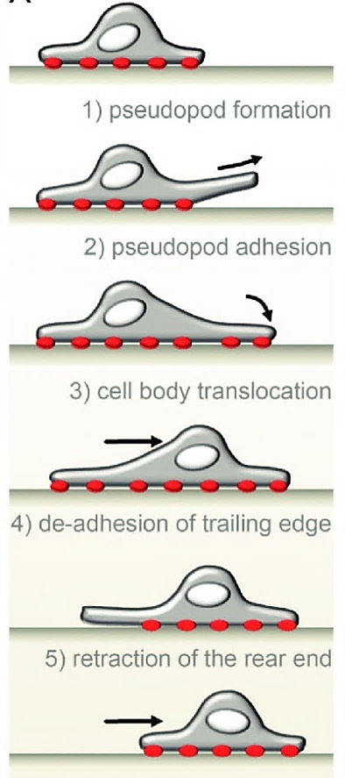  (https://www.researchgate.net/publication/261515905_Podosomes_in_space)
nucleus

The Student Handout description of the cell parts found in all cells does not mention some exceptions. For example, during the final stages of development of mammalian red blood cells, the nucleus and mitochondria are ejected, so mature red blood cells do not have DNA. To help your students understand the terms cytoplasm and cytoskeleton, you may want to tell them that “cyto-" means cell. The membrane that surrounds a cell is often called the plasma membrane, in order to distinguish it from the membranes inside the cell (especially in eukaryotic cells).

In response to question 2a, you may want to mention that, in the initial video, molecular changes in the cytoskeleton proteins caused movement and thus helped the animal cell respond to its environment. Also, some proteins are enzymes that participate in energy metabolism etc., and some proteins are pores and pumps in the cell membrane, which help to maintain homeostasis. In your class discussion of student answers to question 2b, you will want to include (1) the roles of DNA and ribosomes in making proteins which contribute to growth and the other activities of life and (2) how the cell membrane contributes to homeostasis. Students can learn more about the cell membrane in the hands-on activity, “Cell Membrane Structure and Function” (https://serendipstudio.org/sci_edu/waldron/#diffusion).

Question 3 should stimulate students to remember what they have learned previously about animal cells and bacteria, which will help them to link their previous learning to the information in this activity.

The defining difference between prokaryotic and eukaryotic cells is that eukaryotic cells have a membrane surrounding their DNA and prokaryotic cells do not. Eukaryotic means that the cell has a true nucleus (i.e., DNA surrounded by a nuclear membrane). (The word eukaryote comes from the Greek “eu”, meaning true, and “karyon”, meaning nut or kernel. The word prokaryotic comes from the Greek “pro”, meaning before, and “karyon”, meaning nut or kernel.)

The figure on page 2 of the Student Handout defines an organelle as “a part of a cell that has a specialized function”. This definition includes ribosomes. Some sources restrict the definition of an organelle to membrane-enclosed organelles, which excludes ribosomes.

This figure shows more information about a “typical” prokaryotic cell. The cell wall provides structure and protection. The capsule with its pili enables the cell to attach to surfaces in its environment. The DNA is in a circular chromosome (as opposed to the linear chromosomes in eukaryotic cells). Not all prokaryotes have a flagellum. Prokaryotes differ in size, shape, and ability to move. | 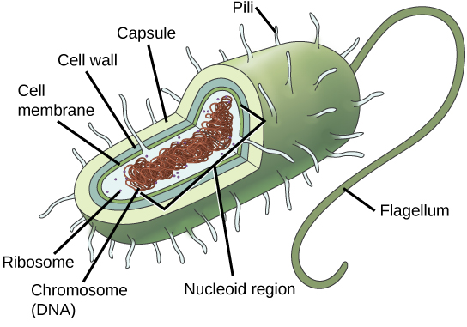  (https://courses.lumenlearning.com/suny-wmopen-biology1/chapter/prokaryotes-and-eukaryotes/)

The animation recommended in question 4d (https://learn.genetics.utah.edu/content/cells/scale/) should help your students develop an intuitive understanding of how tiny cells are. If you want your students to learn that surface-area-to-volume ratio is a major reason why cells are so tiny, you can use Appendix 1.

Although prokaryotes are generally described as unicellular, it has been estimated that 40-80% of all prokaryotes live in biofilms (see figure below). In a biofilm:
- A secreted extracellular substance provides protection.
- Some of the cells have differing metabolisms and functions, and they cooperate to support the survival and propagation of the biofilm.

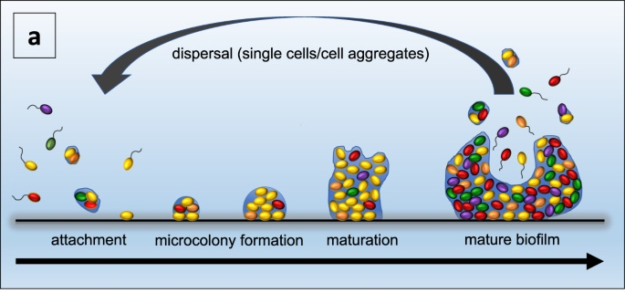
Single, motile prokaryotic cells or cell aggregates attach to a substratum. Then, cells divide and some of the cells secrete extracellular matrix. When a biofilm is mature, it releases single motile cells or cell aggregates which disperse. (https://www.nature.com/articles/s41522-021-00251-2)

Prokaryotes are diverse, numerous, and nearly ubiquitous on earth. Scientists believe that there are millions of different species of prokaryotes alive today, although only about 5000 species have been formally named and described thus far. A teaspoon of good quality soil contains billions of prokaryotes, and a milliliter of ocean water typically contains roughly 10,000 prokaryotes. Scientists estimate that the total number of individual bacteria and archaea alive today is over 5x 10³⁰. They estimate that, despite their tiny size, there are so many prokaryotes that they weigh roughly as much as all the eukaryotes on earth. Research has shown that various prokaryotes can survive in a broad range of environments, including in and on our bodies, in the soil, in the oceans, and in water-filled cracks in the earth’s crust 2.5 km below the ocean floor (at temperatures that range from 0°C to ~120°C and at high pressures; https://www.quantamagazine.org/inside-deep-undersea-rocks-life-thrives-without-the-sun-20200513/). The remarkable metabolic diversity of prokaryotes includes the ability to obtain the energy for the activities of life from sunlight, from organic molecules like sugars, or from inorganic molecules like ammonia or methane.

Prokaryotes are sometimes thought of as “germs” and are assumed to be harmful, but humans derive multiple benefits from prokaryotes. To answer question 5, students can use the two examples described on the top half of page 3 of the Student Handout.

In the Student Handout, the need for nitrogen atoms is attributed to amino acids, but nitrogen atoms are also needed for nucleotides. | 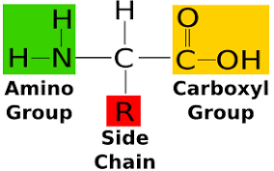  Different amino acids have different side chains. | 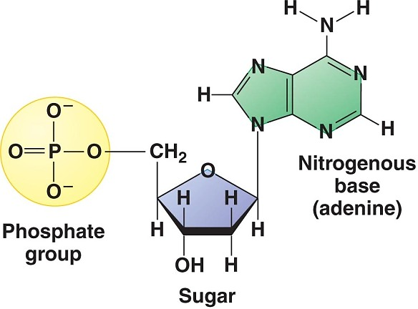  Different nucleotides have different nitrogenous bases.

The figure below shows the important roles of bacteria in the nitrogen cycle. Plants depend on prokaryotes to convert the abundant N₂ in air to NH₄⁺, which plants can use to make amino acids. Animals obtain amino acids from plants (or animals that eat plants).

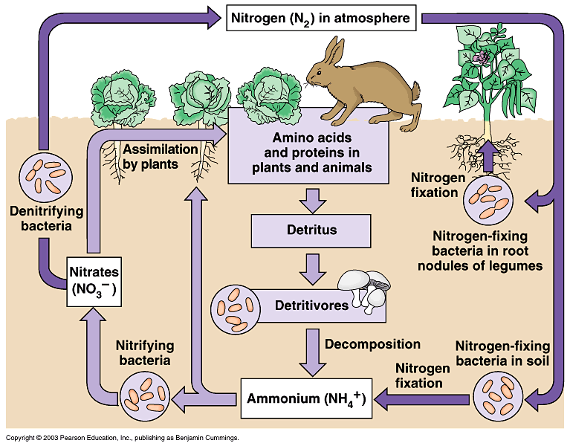
(https://i.pinimg.com/originals/21/e3/66/21e36612329d77271bdcfae88d8232f7.gif)

One study has estimated that a typical man has roughly 30 trillion human cells and 38 trillion prokaryotic cells. Many of the prokaryotes living in or on humans are in the contents of the colon. Because prokaryotic cells are so much smaller than animal cells, the total weight of the prokaryotes living in and on your body is only about 0.2 kg (less than half a pound). The relationship between humans and our microbiome is an example of a mutualistic symbiosis. (See description of mutual benefits on page 3 of the Student Handout. Symbiosis occurs when two different species live together in direct and intimate contact.) A typical woman has roughly 21 trillion human cells (https://journals.plos.org/plosbiology/article?id=10.1371/journal.pbio.1002533). (The sex difference is due primarily to women’s lower number of red blood cells. Red blood cells are estimated to be 84% of human cells.) Another study produced somewhat higher estimates – 36 trillion human cells in a typical man and 28 trillion human cells in a typical woman (https://www.pnas.org/doi/10.1073/pnas.2303077120).

To help your students understand how trillions of cells fit inside a human body, you may want to show them the figure below. You may need to emphasize for your students the logarithmic scale in this figure. This figure provides the basis for estimating that a woman is about 10⁴-10⁵ times as tall as the diameter of an animal cell. We can start from this estimate to calculate how a woman’s body can contain 21-28 trillion = 2.1-2.8 x 10¹³ human cells. To estimate volume, diameter should be cubed, so there is room for roughly (10⁴)³– (10⁵)³ = 10¹² – 10¹⁵ human cells in a woman’s body. These estimates bracket the estimated number of human cells in a woman’s body = 2.1-2.8 x 10¹³.
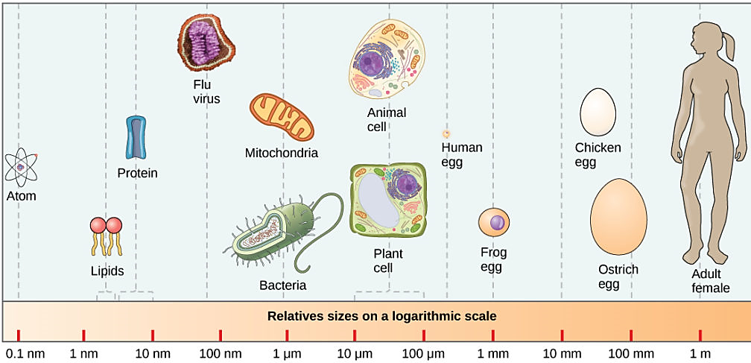
(https://courses.lumenlearning.com/biology1/chapter/comparing-prokaryotic-and-eukaryotic-cells/)

As explained in the recommended 5-minute video, “Prokaryotic vs. Eukaryotic Cells” (https://www.youtube.com/watch?v=Pxujitlv8wc) and on the bottom half of page 3 of the Student Handout, there are two fundamentally different types of prokaryotes – bacteria and archaea. These differences are molecular and difficult for beginning biology students to understand. These molecular differences explain why many antibiotics that can kill bacteria or slow the growth of bacterial populations have little or no effect on archaea (https://www.clinicalmicrobiologyandinfection.com/article/S1198-743X(14)61060-0/fulltext). In some ways, archaea are more similar to eukaryotic cells than to bacteria (as indicated by their evolutionary relationships which are shown in the figure below; https://www.easybiologyclass.com/compare-archaebacteria-bacteria-and-eukaryotes-similarities-and-differences-table/; https://microbenotes.com/archaea-vs-bacteria/).

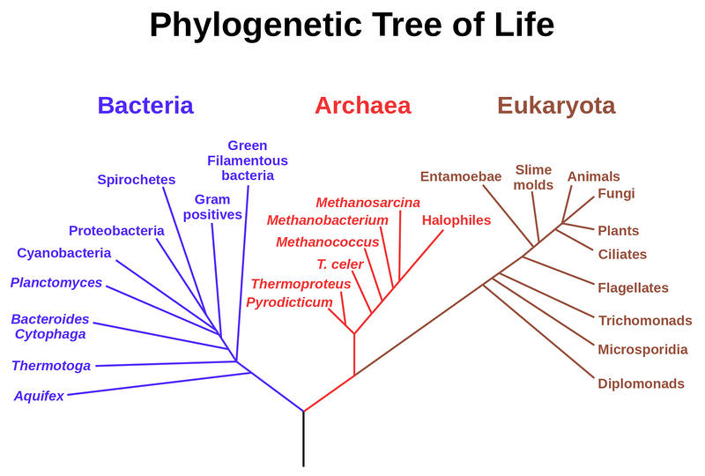
(https://bio.libretexts.org/@api/deki/files/18719/f-d%253Ad598b8a0cba935881318a4c0e6fc8211f272ff6bbd885da2cf0da905_IMAGE_TINY_IMAGE_TINY.1?revision=1)

Good sources for more information about prokaryotes are:
- https://bio.libretexts.org/Bookshelves/Introductory_and_General_Biology/Book%3A_Concepts_in_Biology_(OpenStax)/13%3A_Diversity_of_Microbes%2C_Fungi%2C_and_Protists/13.1%3A_Prokaryotic_Diversity
- https://www.coursehero.com/sg/introduction-to-biology/prokaryotes-bacteria-and-archaea/ (including a 6.5-minute video)

To help students understand the figure in question 8, you may want to explain that mitochondrion is the singular of mitochondria. Mitochondria are shown as oval organelles, but in real cells the mitochondria are highly dynamic, changing shape, sometimes growing and dividing to form new mitochondria. In discussing mitochondria, be careful to avoid the common error of saying that mitochondria make energy; mitochondria use the energy available from reactions between glucose and oxygen to make ATP molecules (see “How do organisms use energy?”; https://serendipstudio.org/exchange/bioactivities/energy). Students can learn more about the structure and function of mitochondria in “Using Models to Understand Cellular Respiration” (https://serendipstudio.org/exchange/bioactivities/modelCR).

Lysosomes contain digestive enzymes that break down damaged organelles and macromolecules into smaller molecules (e.g. amino acids, nucleotides or monosaccharides), which are reused by the cell. As shown in the figure below, lysosomes fuse with membrane-bound vacuoles, so lysosomal enzymes can digest worn out organelles and molecules without damaging healthy cytoplasm. If you want your students to learn more about the formation and functions of lysosomes, you can show them the 1-minute video, “Lysosomes” (https://www.youtube.com/watch?v=isYEMzeanP0).

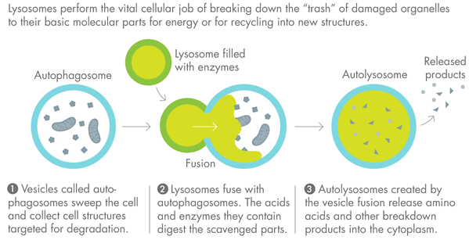
(https://leisureguy.files.wordpress.com/2017/04/creativedestruction-615_double-615x374.png)

The figure on the bottom of page 4 of the Student Handout shows the basic process that transports proteins from the rough endoplasmic reticulum to the Golgi apparatus and from the Golgi apparatus to the cell membrane. An explanation of how a motor protein (kinesin) walks along a microtubule (part of the cytoskeleton) is available from approximately 3 minutes to 6 minutes in the video, Kinesin Structure and Function (https://www.youtube.com/watch?app=desktop&v=FwNVHiTOANM). Question 9 is designed to reinforce student understanding that vesicles are moved by motor proteins traveling along microtubules, which are part of the cytoskeleton.

Question 10 reinforces student understanding that different parts of a eukaryotic cell work together to accomplish cell functions. For example, the following describes how organelles cooperate to synthesize and secrete proteins such as insulin or antibodies. The information in the DNA in the nucleus is copied to mRNA. The information in the mRNA is used by ribosomes to synthesize proteins. Many secreted proteins have carbohydrates attached; the carbohydrate is often bonded to the protein in the rough endoplasmic reticulum and processed by removal, substitution or modification of a sugar monomer in the Golgi apparatus. (These processes are summarized in the figure below.) The energy for these processes is provided by ATP which is made by the mitochondria. These processes also produce the proteins that are inserted in the cell membrane. More detail is available at https://www.ncbi.nlm.nih.gov/books/NBK26941/.
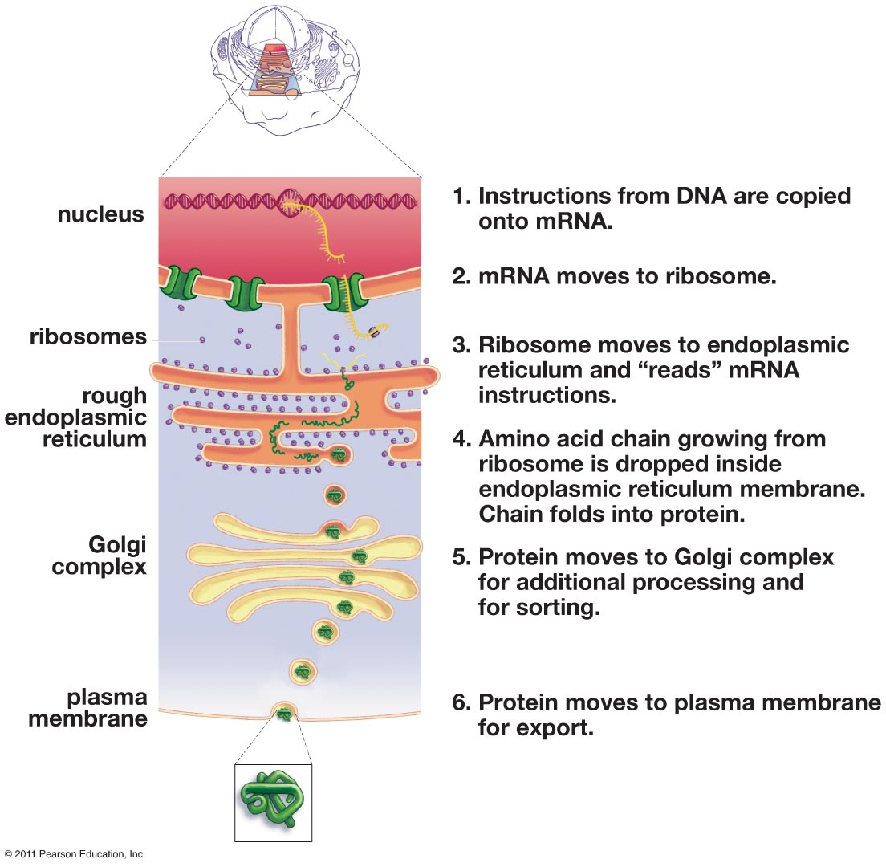
In this figure the cell membrane is called the plasma membrane and the Golgi apparatus is labeled as the Golgi complex.
(From Krogh, Biology - A Guide to the Natural World, Fifth Edition)

The recommended ~3-minute excerpt from the video, “The Inner Life of the Cell” (https://www.youtube.com/watch?v=QplXd76lAYQ&t=282s), should help students to appreciate the dynamic activity inside cells. The narration of this video is quite technical. You may want to:
- listen to the narration and then turn off the sound and substitute your own, more student-friendly narration or
- have your students listen to an 11.5-minute version with easier to understand explanations, available at https://www.youtube.com/watch?v=dp6qRNNGPj4.
This animation is quite scientifically accurate. However, it should be noted that motor proteins actually make up to 100 steps per second (https://news.mit.edu/2008/cell-motor-1124). For your class discussion of this video, you may want to include additional information about the dynamism of cells, including:
- A eukaryotic cell can produce hundreds of protein molecules per second; the ribosomes in these cells typically add two amino acids per second to a growing polypeptide.
- A typical cell in a human body uses an average of 10 million ATP molecules per second and produces an equal amount of replacement ATP molecules.
- Mitochondria are replaced approximately every 10 days.
- Many cells in the body are constantly being replaced, e.g. skin cells and the epithelial cells that line that gut.
(Source: Freeman et al., Biological Science, Fifth Edition)

As suggested in question 11a, you may want to show your students a 0.5-minute video of sperm
swimming (https://sites.tufts.edu/guastolab/movies/). This figure shows how small human sperm are relative to a human egg. Sperm have very little cytoplasm, whereas the egg is a very large cell with a lot of cytoplasm. Once the egg has been fertilized, this large amount of cytoplasm is useful to supply the cytoplasm for the multiple cells that are produced by the cell divisions which occur while the conceptus is traveling down the oviduct and before the developing embryo implants in the wall of the uterus. | 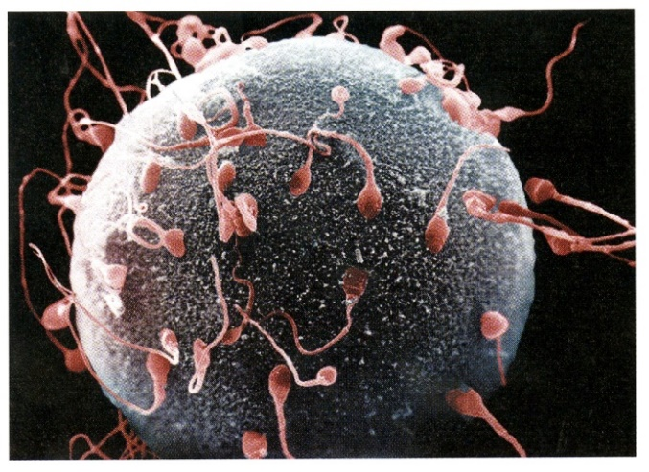  (Figure from Krogh, Biology --  A Guide to the Natural World, Fifth Edition)

Question 12 returns to the initial anchoring phenomenon, but this time inside a eukaryotic organism. To help your students remember the term phagocyte, you may want to tell them that “phago” means eat, and “cyte” means cell. You may also want to define capillaries as the smallest blood vessels. For more information about the process of phagocytosis, see the figure below and https://teachmephysiology.com/immune-system/innate-immune-system/phagocytosis/.

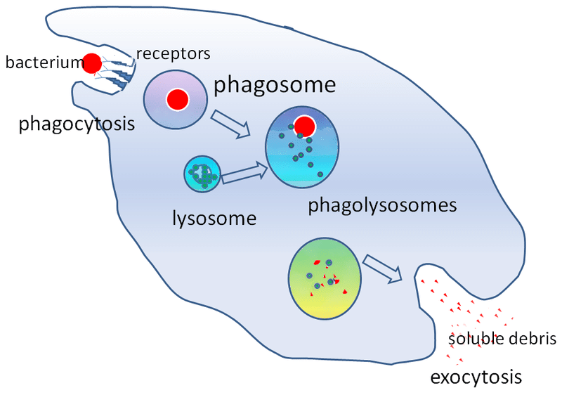
(https://teachmephysiology.com/immune-system/innate-immune-system/phagocytosis/)

Students can learn more about the diversity of animal cells in “How do food molecules reach our muscles? – Organ Systems, Organs and Cells” (https://serendipstudio.org/exchange/bioactivities/SFCellOrgan). Additional information about eukaryotic cells is available in https://openstax.org/books/concepts-biology/pages/3-3-eukaryotic-cells.

Some important differences between plant and animal cells are shown in the figure in the upper half of page 7 of the Student Handout. These differences are best understood in the context of differences in how plants and animals obtain the organic molecules that are needed for cellular respiration and needed for synthesizing new molecules for growth and repair. Obviously, plant cells need chloroplasts to photosynthesize, whereas animals eat food. Plants’ ability to photosynthesize means that plants do not require the mobility that many animals need to obtain food, so the rigidity of cell walls and the weight of the solution in the central vacuole are not significant disadvantages for plant cells. The turgor pressure in the central vacuole of plant cells works together with the cell wall to maintain plant structure. In contrast, animals are generally supported by a skeleton or buoyancy in water. These observations illustrate that the adaptive value of a given characteristic varies, depending on the other characteristics of an organism. These considerations also provide another example of how structure matches function.

Question 15 revisits differences between prokaryotic and eukaryotic cells and differences between plant and animal cells. Before question 15, you may want to show the 7-minute video, “Biology: Cell Structure”, which reviews these topics (https://www.youtube.com/watch?v=URUJD5NEXC8). One inaccuracy in this video is that the narrator states that proteins are folded in the Golgi apparatus, whereas actually proteins are folded in the rough endoplasmic reticulum.

If you want your students to learn about a unicellular eukaryote, you can add the Challenge Question on Paramecium shown in Appendix 2.

Recommended Follow-Up Activities
Cell Membrane Structure and Function
http://serendipstudio.org/sci_edu/waldron/#diffusion
This activity includes two hands-on experiments and numerous analysis and discussion questions to help students understand how the characteristics and organization of the molecules in the cell membrane result in the selective permeability of the cell membrane. In the hands-on experiments, students first evaluate the selective permeability of a synthetic membrane and then observe how a layer of oil can be a barrier to diffusion of an aqueous solution. Students answer analysis and discussion questions to learn how the phospholipid bilayer and membrane proteins play key roles in the cell membrane function of regulating what gets into and out of the cell. Topics covered include ions, polar and nonpolar molecules; simple diffusion through the phospholipid bilayer; facilitated diffusion through membrane proteins; and active transport by membrane proteins. An optional additional page introduces exocytosis and endocytosis. (This activity supports the Next Generation Science Standards = NGSS.)

How do food molecules reach our muscles? – Structure and Function of Organ Systems, Organs and Cells
https://serendipstudio.org/exchange/bioactivities/SFCellOrgan
In this analysis and discussion activity, students answer minds-on questions to learn how food is digested and the digested molecules reach their muscles. They analyze multiple examples of the relationship between structure and function in the cells and organs of the digestive system. Students analyze examples that illustrate how organs and organ systems work together to accomplish functions needed by the organism. Finally, students use a claim, evidence and reasoning framework to evaluate the claim that structure is related to function in cells, organs and organ systems.

Sources for Figures in Student Handout
- Eukaryotic and prokaryotic cells – modified from https://sciencing.com/prokaryotic-vs-eukaryotic-cells-similarities-differences-13717689.html
- Animal cell (in question 8) – modified from https://s3.thingpic.com/images/ec/nwgJCGPHG9frbEHXeXy92knq.png
- Motor protein walking along microtubule – modified from https://www.instagram.com/microbiologyupdate/p/CzS4GxHxcPB/
- Diagram of protein secretion – modified from https://image.slidesharecdn.com/07cellorganelle-100215190111-phpapp01/85/07-cell-organelle-39-320.jpg?cb=1668429712
- Phagocytosis – modified from https://slideplayer.com/slide/13987131/86/images/24/Inflammatory+Response.jpg
- Diagram of animal and plant cells – modified from Krogh, Biology – A Guide to the Natural World, 5th Edition

Appendix 1 – Possible Addition to the Student Handout Concerning Cell Size
(after question 4)

To understand why cells are so tiny, we need to think about how size affects the supply of a substance (e.g. O₂) relative to the need for the substance.
- The rate of diffusion of O₂ into a cell is proportional to the surface area of the cell.
- The rate of using O₂ is proportional to the volume of the cell.
Therefore, a cell can only survive if it has enough surface area relative to its volume.

5a. Complete this table to learn how the surface-area-to-volume ratio changes as size increases.

Hypothetical Cube-shaped Cells | Surface area (total  area of all six sides) | Volume | Surface-area-to-volume ratio
A  Length of each side = 1 µm | ______ µm² | ______ µm³ | ___ : ___
B  Length of each side = 10 µm | ______ µm² | ______ µm³ | ___ : ___

5b. In comparison to cell A, the length of each side is _____ times bigger for cell B,
the surface area is _____ times bigger for cell B, and
the volume is ______ times bigger for cell B.

6. Explain why cells are tiny. What problem would larger cells have?

Teacher Notes
As cell size increases, the surface-area-to-volume ratio decreases. Therefore, cells need to be tiny. The calculations in question 5a above are presented for a hypothetical cuboidal cell, since these calculations are relatively easy. The trends in surface-area-to-volume ratio will be similar for a spherical cell; if r is the radius of the sphere, surface area is proportional to r², volume is proportional to r³, and the surface-area-to-volume ratio is proportional to 1/r. Thus, the surface-area-to-volume ratio for either a cube or a sphere decreases as it gets larger.

Since substances like O₂ enter the cell by diffusion across the cell membrane, cell surface area limits the supply of these substances. (Some other molecules and ions are actively pumped into cells.) ("Cell Membrane Structure and Function"; https://serendipstudio.org/exchange/waldron/diffusion)

Surface area increases if the cell has thin extensions (e.g. the axons and dendrites of neurons).
This explains why diffusion across the cell membrane can supply enough O₂ for the long slender axons of the nerve cells that extend from the bottom of your spine all the way down your leg to your foot. | 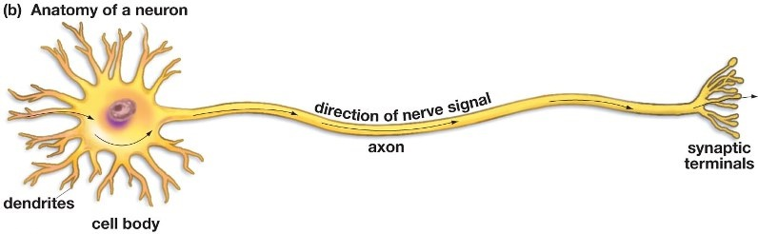  (From Krogh, Biology – A Guide to the Natural World, Fifth Edition)
Appendix 2. Possible Challenge Question to Add to End of Student Handout

16. A paramecium is a single cell organism. The structure of this eukaryotic cell differs from “typical” animal and plant cells. Use a reliable source such as a textbook to learn about the functions of the structures shown in this diagram. Explain how these structures support the paramecium’s activities of life (e.g., maintaining homeostasis, responding to the environment, and getting and using energy).

Teacher Notes
This question provides another example of the diversity of eukaryotic cell structure. It also challenges students to develop their skills in obtaining and evaluating information. A useful resource for students to learn about Paramecia is available at https://en.wikipedia.org/wiki/Paramecium. You may also want to recommend the first 2 minutes of Paramecium Tutorial (https://www.youtube.com/watch?v=mh7KOtQTXrw) which shows the motion of cilia, food being swept into the oral groove, and contraction of the contractile vacuoles for osmotic regulation. Seeing this video will help students understand the constant, dynamic activity in cells.

By Dr. Ingrid Waldron, Department of Biology, University of Pennsylvania, © 2024. These Teacher Notes and the Student Handout are available at https://serendipstudio.org/exchange/bioactivities/Cells.
Quotations are from https://www.nextgenscience.org/ and http://www.nextgenscience.org/sites/default/files/HS%20LS%20topics%20combined%206.13.13.pdf
To draw a shape - At the top of the page, find and click Shape. - Choose the shape you want to use. - Click and drag on the canvas to draw your shape. To insert text - At the top of the page, click Insert. - To place text inside a box or confined area, click Text Box and drag it to where you want it. - Type your text. - You can select, resize and format the word art or text box, or apply styles like bold or italics to the text. When you are done, click Save and Close.
In contrast, billions of years ago cells arose by evolution from aggregates of molecules.
As discussed in the “Characteristics of Life” activity, the distinction between living and non-living things is not clear-cut. For example, viruses are intermediate between living and non-living things, since they have several characteristics of life but lack many others.
The description of cytoplasm on page 1 of the Student Handout does not make it clear that the cytoplasm of eukaryotic cells does not include the nucleus, so you may need to clarify that.
Recent research has shown that many prokaryotic cells have more internal structure than was previously believed. Various prokaryotes have internal membranes, including one species of bacteria that has a membrane around its DNA (https://journals.plos.org/plosone/article?id=10.1371/journal.pone.0091344). This species can be recognized as a prokaryote because it has a circular chromosome.
In prokaryotic cells, in addition to the circular chromosome, there are often small circles of DNA called plasmids, which can be exchanged between prokaryotic cells, even of different species. In eukaryotic cells, in addition to the DNA in the nucleus, there is DNA in the mitochondria and, for plant cells, also in the chloroplasts. This is one reason why most biologists believe that eukaryotic cells evolved, in part, by one or two endosymbiotic events (a prokaryotic cell that lives inside another cell evolves into an organelle in a eukaryotic cell).
If you want to reinforce the relative sizes of molecules and cells, you can use the Card Sort Activity, From Coffee to Carbon, available at https://teach.genetics.utah.edu/content/cells/files/Coffee-to-Carbon.pdf. This activity has students sort cards (each with a molecule, organelle or cell) according to size. To use this card sort activity to reinforce student understanding of the relationship between molecules and cells, I recommend that you begin by having your students sort the cards into four categories: molecules, organelles, cells, and other. After you have discussed this initial card sort, then have your students organize the cards from smallest to largest. (Depending on your students, you may want to omit some cards such as adenine and baker's yeast.) This card sort would complement the recommended animation (https://learn.genetics.utah.edu/content/cells/scale/). The orders of magnitude differences in size can be used to help students realize that eukaryotic cells are made up of many many organelles and each organelle is made up of many many molecules.
Very recent research has identified one type of eukaryotic marine alga that has a nitrogen fixing organelle that has evolved from a nitrogen fixing endosymbiotic bacterium. This is similar to the way that mitochondria and chloroplasts evolved from endosymbiotic bacteria (https://www.science.org/doi/10.1126/science.ado8571).
If you want to reinforce the most important information in the recommended video, you may want to show the 2.5-minute video, “Learn About the Similarities and Differences Between Eukaryotic and Prokaryotic Cells” (to find the video, scroll down at https://www.britannica.com/science/cell-biology/images-videos). This video uses a definition of organelles that excludes ribosomes, which is different from the definition in this activity.
Some scientists argue that bacteria and archaea are so different that we should stop using the term prokaryotes. These scientists fear that the use of the term “prokaryotes” could be misinterpreted to mean that bacteria and archaea are more closely related evolutionarily than archaea and eukaryotes. Contrary to this potential misinterpretation, contemporary molecular research indicates that archaea and eukaryotes are more closely related evolutionarily, and some archaea may even have been the evolutionary ancestors of eukaryotes (https://www.frontiersin.org/articles/10.3389/fmicb.2018.01896/full#:~:text=A%20Briefly%20Argued%20Case%20That%20Asgard%20Archaea%20Are%20Part%20of%20the%20Eukaryote%20Tree,-Gregory%20P.&text=The%20recent%20discovery%20of%20the,origin%20of%20the%20eukaryote%20cell). In this activity, I have taken the point of view that the term “prokaryotes” is a convenient shorthand for cells which do not have a true nucleus and is suitable for use in this introductory activity.
For a review of the inconclusive evidence of a relationship between archaea and the risk of human disease, see https://www.ncbi.nlm.nih.gov/pmc/articles/PMC4466265/. The most persuasive evidence supports a causal relationship between a methanogenic archaea species and periodontal disease.
To give students a better understanding of transcription and translation (DNA→ mRNA → proteins), you may want to use the hands-on activity, "From Gene to Protein – Transcription and Translation" (https://serendipstudio.org/sci_edu/waldron/#trans) or the analysis and discussion activity, "From Gene to Protein via Transcription and Translation (https://serendipstudio.org/exchange/bioactivities/trans).
The sphere in the middle of the nucleus in each diagram is the nucleolus, where ribosomes are produced (https://www.britannica.com/science/ribosomal-RNA).
Students can learn more about the structure and function of chloroplasts in the analysis and discussion activity, “Using Models to Understand Photosynthesis” (https://serendipstudio.org/exchange/bioactivities/modelphoto).
The figure in the question is modified from https://www.pngitem.com/pimgs/m/374-3745167_nutrition-in-paramecium-diagram-hd-png-download.png.

